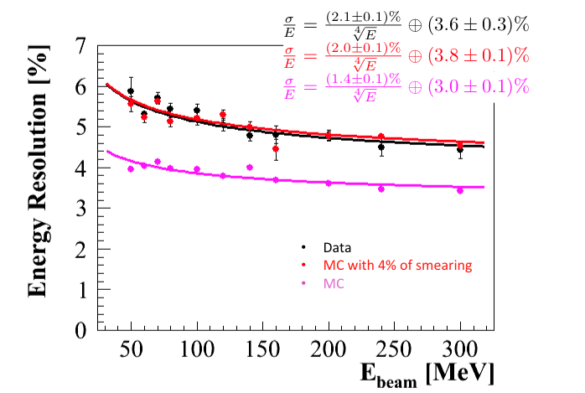Figure .1. *Test Beam results from MAMI. The measured energy resolution of the overall LYSO crystal matrix (black points) is compared to simulations (red). To obtain reasonable agreement with the data, the energy response of each crystal was smeared by 4% in the simulation (blue).*

# 1.6 Test beam and experimental measurements

To validate the reliability of the calorimeter simulation different sets of measurements were carried out. A summary of the old measurements, shown in the Mu2e CDR [ref] for the LYSO crystals, is briefly reported in this introduction, while the most recent measurements performed both with a new LYSO matrix prototype and single *alternative* crystals are reported in the following sub-sections. A perspective for the next R&D planning is also presented.

A LYSO array was exposed to a test beam at the MAINZ Microtron (MAMI) in March 2011. For this beam test, 9 SICCAS LYSO crystals were used at Frascati National Laboratory (LNF) to assembly a crystal matrix. The LYSO crystals, 20×20×150 mm3, were read out by a single S8664-1010 APD and were surrounded by a leakage recovery matrix of PbWO4 crystals, read out by conventional Hamamatsu PMTs. The total coverage for the matrix was ~ 2.5 RM. Each channel was calibrated to approximately 2% by means of cosmic rays. The APDs were operated at an average gain of ~300. The crystals were exposed to a tagged photon beam with energies ranging from 20 up to 400 MeV. Data were taken at twelve different energies over a period of 2 days. Figure 0.1 shows the dependence of the energy resolution as a function of beam energy for test beam data (black) and for the simulation (red). The resolution dependence was fit with the following parameterization:



where a is the stochastic term, b is the noise term and c is the constant term. The experimental points are well represented by an a term of 2.4% with an E1/4 dependence, a negligible electronic noise term and a constant term of 3.2% due to shower leakage. To obtain reasonable agreement with the data, the energy response of each crystal was smeared by 4% in the simulation using a Gaussian distribution. Details of the measurement can be found in [NIMs]. The additional Gaussian smearing was introduced as the fastest way to simulate the expected non-uniformity or non-linearity existing inside the crystals. All in all, this granted a 5.3% energy resolution that was still improvable due to the small dimension of the matrix and to the not perfect quality of the obtained LYSO crystals.

Other two sets of measurements were carried out : (i) a position measurement with the Mami photon beam, that resulted in an observed resolution of ~ 3 mm at 90 degrees, as limited by the beam dimension and (ii) a timing resolution test carried out with electron beam at the BTF facility in Frascati, Italy. As reported in ref [NIM-old], the LYSO timing resolution was measured to be of ~ 200 ps in the energy range 100--500 MeV.

In the next sub-section, the new results, obtained with a test done at the BTF electron beam in 2014 and with a larger size prototype, are presented The last two sections will describe the measurement of single crystals read-out with different photo-sensors to improve our experimental knowledge of *alternative* crystals.

**1.6.1 Measurement at BTF with a new LYSO array**

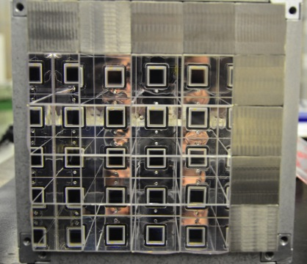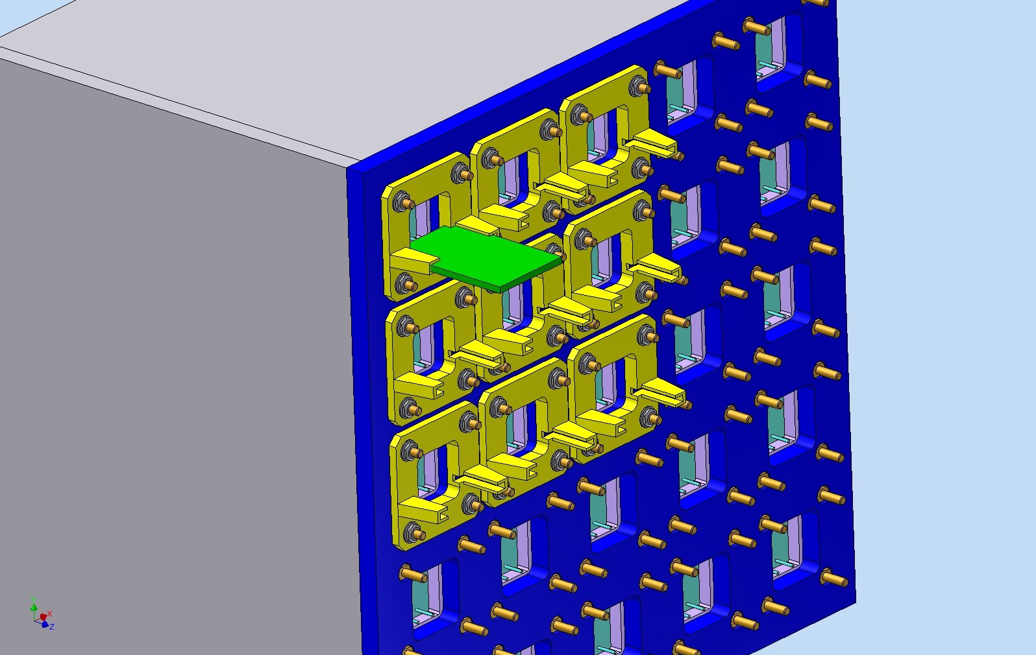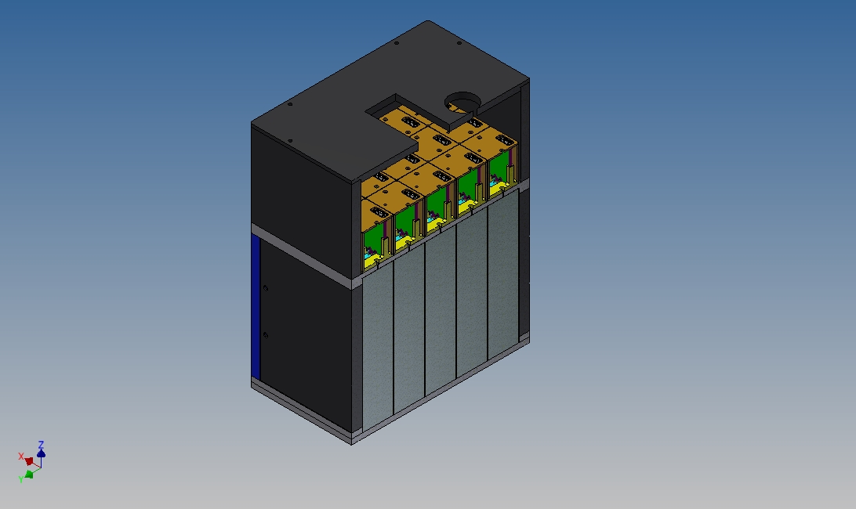

Figure .2 (*Left) CAD drawing of the readout side of proto-1, (center) CAD view of the assembled matrix, with crystals, APD and FEE boxes and tight light box. (right) picture of the matrix during the assembly.*

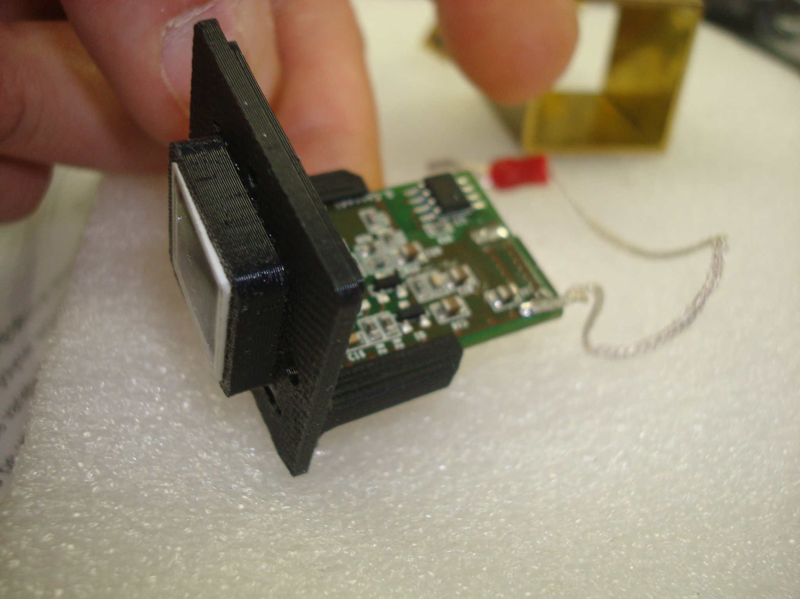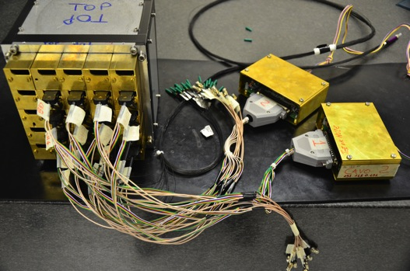

Figure .3 *(Left) picture of a FEE prototype connected to the APD and inserted in the APD-FEE holder done with a 3D printing. (Right) connection of the amp-HV chips to the ARM readout controllers. The black bundle, with green caps, is the Fused Silica fibers coming from the light distribution sphere from the Laser prototype system.*

In order to complete our R&D program for the LYSO, a larger and more uniform crystal matrix has been built. A CAD drawing and a picture of the assembled prototype are shown in Fig. 2.left, 2.right respectively. Few differences can be enlightened with respect to the old prototype: the crystal dimension is much closer to the final one and the array is constituted by 25 identical square crystals of 30x30x130 mm3 dimension. The ratio, Rapd, between the active area of the photo-sensor and the crystal transversal area is consistent with the one of the selected hexagonal shape. The crystals, all wrapped with an improved ESR-3M reflector, providing a 30% more light yield than Tyvek, were all measured at the transmission and response test station and their light yield and LRU measured (see sect. XX). Uniformity and transmittance found were excellent. The longitudinal length, in X0,  is slightly smaller than in the final detector if considering the average length correction due to the impinging angle of 50 degrees for the CE candidates. The Front End electronics, Fig.3, is constituted by 16 prototypes of the AmpHV chip, with HV set and monitored by two readout ARM controllers as in the final layout. To screen the FEE from external noise sources, the APD and FEE were inserted in a brass box working as a Faraday cage. All chips are connected by means of soldered wire to the same external ground. The DAQ readout uses an array of four CAEN-1720 digitizers with 12 bits resolution and a sampling of 250 msps. These characteristics are very similar to the ones for the custom digitizer boards under development at Illinois ad Pisa Universities. A first version of the Laser calibration system is also used. In Fig.4, a detail of the distribution system and of the optical fiber entering in the back crystal face is shown. A simplified cooling system has also been used during the test by flowing cold air in the FEE region. A temperature monitor, based on a PT-100 sensor, was inserted close to the central crystal and photo-sensor box.

A week of data taking has been carried out in February 2014 at the Frascati BTF facility by sending e- beams between 100 and 300 MeV. The average number of electrons per event has been set to 0.5 in order to observe 0, 1, 2, 3 electrons with a probability of 10%, 60%, 20%, 10% respectively. Two pair of finger scintillators were used for triggering and selection purposes. A fiber tracker array, done by 16 (8 horizontal, 8 vertical) fiber bundles has also been used for position purposes. Each bundle, constituted by four 1 mm2 square blue emitting Kuraray fibers, was optically connected and readout by 1 anode of the SENSL SIPM array (xxxxxxx) providing a reasonably high (S/N~ 6) efficiency and ~1 mm position resolution. For this test, only 16 crystals were available. Another test with a complete matrix will be carried out at BTF at a latter stage. One week of data taking is planned for Mainz in September 2014. In the following sub-section we summarize the first results obtained.

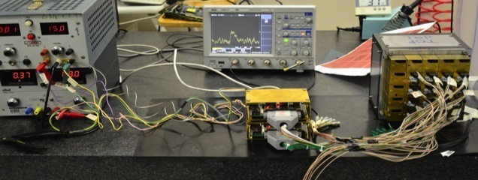

Figure .4 LASER PROTOTYPE SYSTEM IN THE MATRIX

***Calibration with cosmics***

A cosmic ray setup, constituted by two NE-110 plastic slab scintillators (50x50x200 mm3) positioned one above and one below the matrix prototype, has been used to test and calibrate the prototype by triggering on the counters. Two days of continuous data taking were carried out by monitoring continuously also the APD gain, set to 50, when firing the Laser calibration system at 1 Hz rate. In Fig.5, the distributions of the noise and the shape of the minimum ionizing peak, MIP, for the 16 channels are shown. The noise has a Gaussian shape with 1 pC r.m.s., while the MIP peak corresponds to around 200 pC thus providing a equivalent noise of ~ 150 keV/channel. The ΔT distribution for cosmics, between two crossed cells, is consistent with a Gaussian distribution of width 180 ps.

***Stability of data-taking***

The stability of data taking was excellent. We have monitored the pulse height stability by integrating each hour laser pulse and by performing two ratios: (i) RL, between each channel and the channel n.1 and (ii) RPIN,between each channel and the reference pin-diode. Correlation with the temperature of the system is also presented (I hope).

***Calibration with electron beam***

After calibrating the detector with MIP and Laser runs, we have also fired the electron beam in each cell center to compare the calibration scale. We found ?.

***Results for energy, timing and position resolution***

To evaluate the energy response, Etot, only the cells above a given threshold has been used. The threshold was varied from 1 to 7 pC (i.e. from 150 to 1 MeV) and results presented as a function of the applied threshold. The fired cells were summed in a simple way as follow: Etpt = SUM (Ei/Mi) X k, where Ei and Mi are the measured value of the charge integrated in 400 ns and Mi are the calibration values obtained with MIP, Laser and electron beam. K is the absolute calibration scale factor corresponding to 100 MeV. In Fig. XX, the distribution of Etot is reported as a function of the applied threshold. In Fig. YY, the energy resolution is also shown as a function of the beam energy. We obtained: S/E = XX.

To determine the time resolution, we have applied a very simple algorithm to the digitized pulses as follows: …, we have also checked that .. We got St=XX ps.

To measure the position resolution .. fiber tracker

To measure the dependence on angle .. we have taken data also at 45 degrees.

**1.6.2 Measurement of alternative crystals**

reported; the noise is Gaussian with 1 pC r.m.s. while the MIP corresponds to around 200 pC thus providing a equivalent noise of 150 keV/channel. The DT distribution for cosmics is consistent with a Gaussian distribution of width …

**Measurement with the Source and UV extended PMT**

We have measured three alternative crystals, BaF2, CsI, PBWO4. The measurements done with the source and PMT, proved that both BaF2 and the CsI(pure) crystals from SICCAS have a reasonable light output with the expected ratio of fast and slow components, while the PbW04 has a reduced light output. In order to avoid problems, the test with CsI was done in a clean room with a 33% humidity controlled environment. A vacuum bag has been used to encapsulate the crystal when not under measurement.

**Measurement with cosmics rays and large area SiPM**

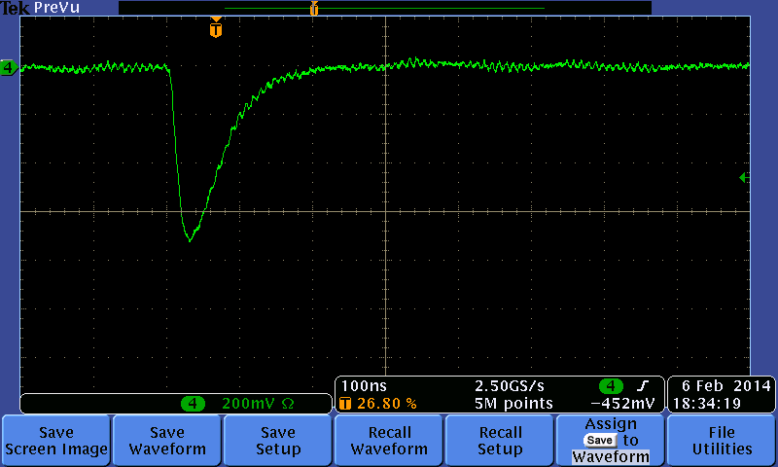

Figure .2 (*Left) distribution of the signal shape for one single m.i.p. event in the CsI(pure) crystal readout by a 12x12 mm2 MPPC array. The time scale is in 4ns bins. (Right) distribution of charge in a.u. for the selected m.i.p. events.*

The measurements done with the source and PMT, proved that both BaF2 and the CsI(pure) crystals from SICCAS have a reasonable light output with the expected ratio of fast and slow components. Given the small size of UV extended SiPm in our hands, the most performing crystal and photo-sensor combinations were that of a CsI (Pure) with a 12x12 mm2 MPPC readout and a BaF2 with an Hamamatsu APD UV extended readout.

The CsI(pure) was wrapped in ESR-3M reflector and a standard array of 16 3x3 mm2 MPPCs, with 50 μm pixel, was used as photo-sensor followed by a prototype discrete amplifier described in sec.xx. The amplifier was used to sum the signals from the 12 anodes providing a total signal width of 100 ns when pulsing the MPPC with a 50 ps pulsed blue laser. The QE of this MPPC at 310 nm is ~ XX % that is in good agreement with the one of the UV-extended PMT. The photo-sensor was optically connected to the crystals by means of a BC-630 optical grease. Similarly to the PMT case the signal presents a rise-time of 25 ns and a two components decay-time. They have been fitted with exponential shapes and resulted to be: tau1 = 10 ns, tau2=30 ns with a S/F ratio of X%. In Fig.0.2.right, the distribution of the pulse height integrated in 400 ns is shown for the events selected by a coincidence between two finger scintillators posed above the crystal itself. The pulse height exceeds 600 mV when running the SiPM at 73 V, while the collected charge corresponds to ~ 1000 pC. The average energy deposition is equivalent to 15 MeV and the energy resolution for a MIP is 14%. By using a Geant-4 simulation, we estimated this width to be equivalent to a photo-electron yield of XXX. In Fig.0.3 the time difference between the two finger scintillators and the difference between a finger scintillator and the CsI timing are shown. A time resolution of ~ 800 ps is measured for a MIP deposition for the CsI, with an associated trigger time-jitter of ~ 300 ps. Scaling down this result to 100 MeV we expect to get 300 ps/channel , 200 ps per cluster for a CsI.

BaF2? equivalent to 15 MeV and the energy resolution for a MIP is 14%. By using a Geant-4 simulation,

**Measurement with the beam at BTF**